Below is a screenshot of my (homepage) before it got feedback.

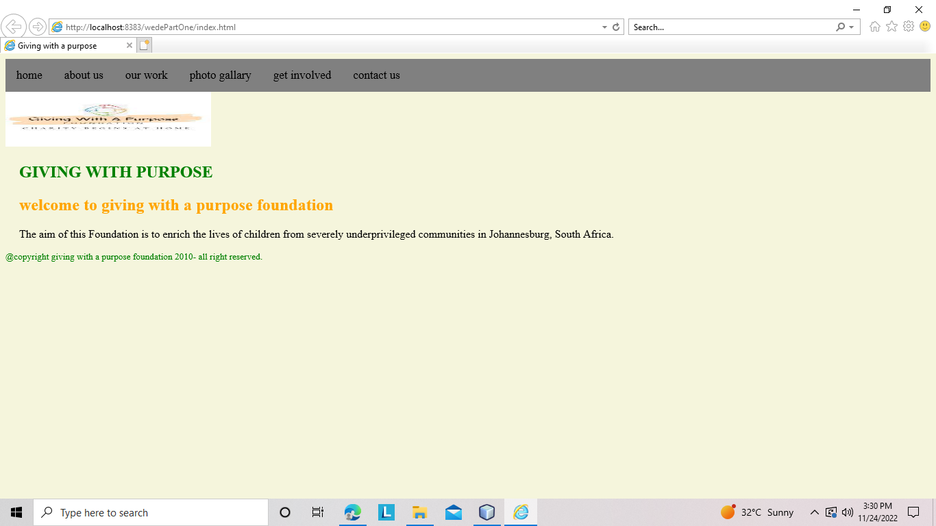

After I got feed back , I improved on the background colour, font , and the way the text is displayed. I made sure that the home page is well designed and it looks appropriate

The screenshot below shows how i improved and styled my homepage after I got feedback :

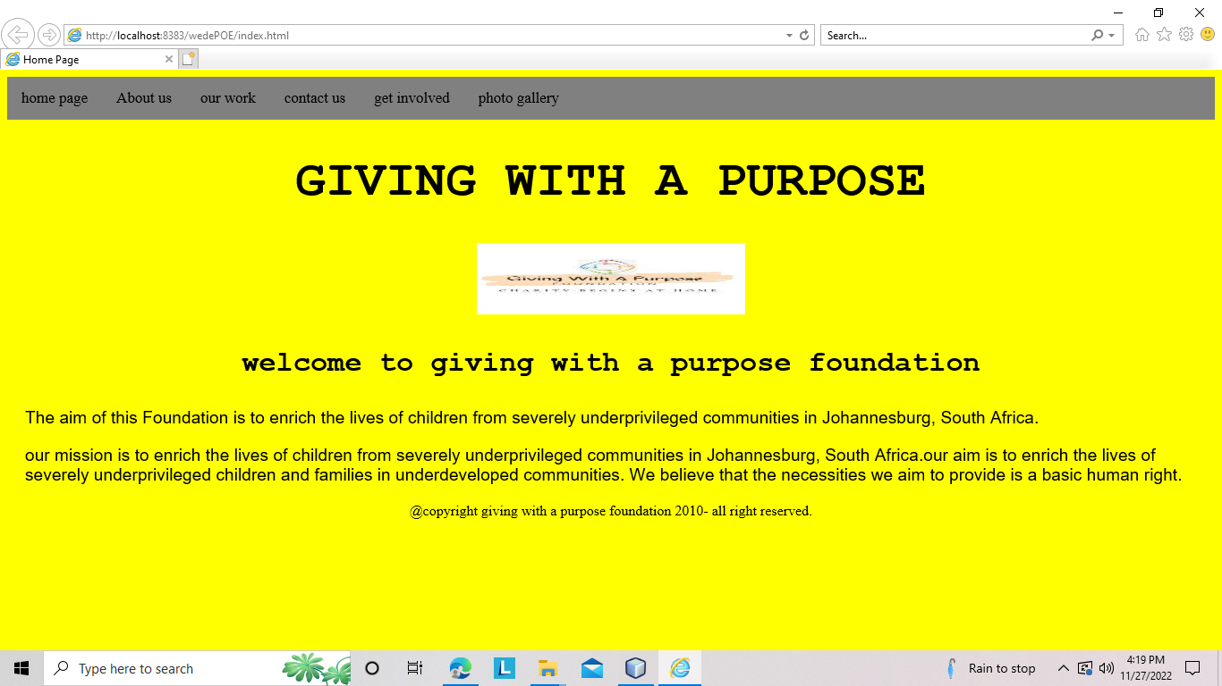

The screenshot below shows how my gallery page look like for part one:

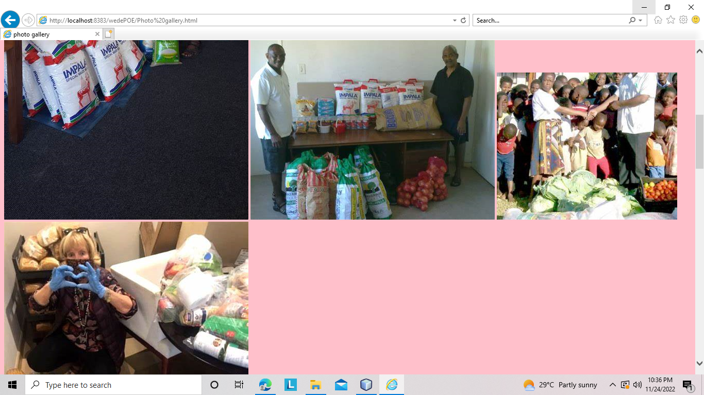

After I got feed, I improved the way my gallery looks and by making sure the pictures are well displayed and it is styled properly. The screenshot below shows how my photogallary has improved for part 2:

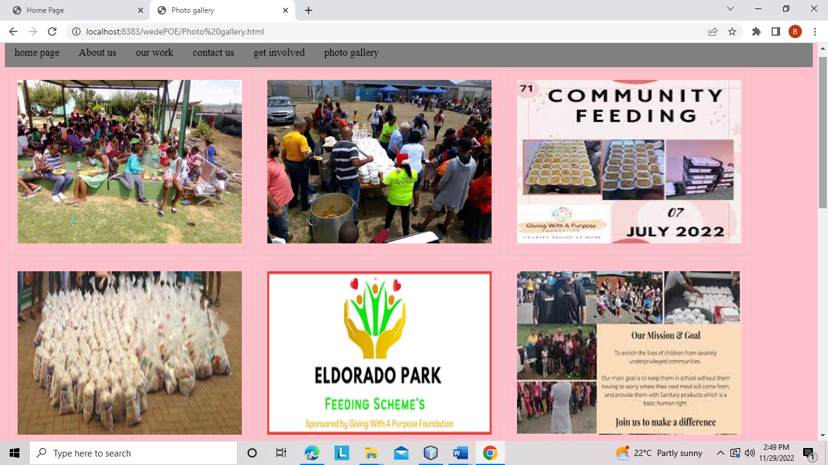

The screenshot below shows how my get involved page looked like for part 1 before I got feedback on it:

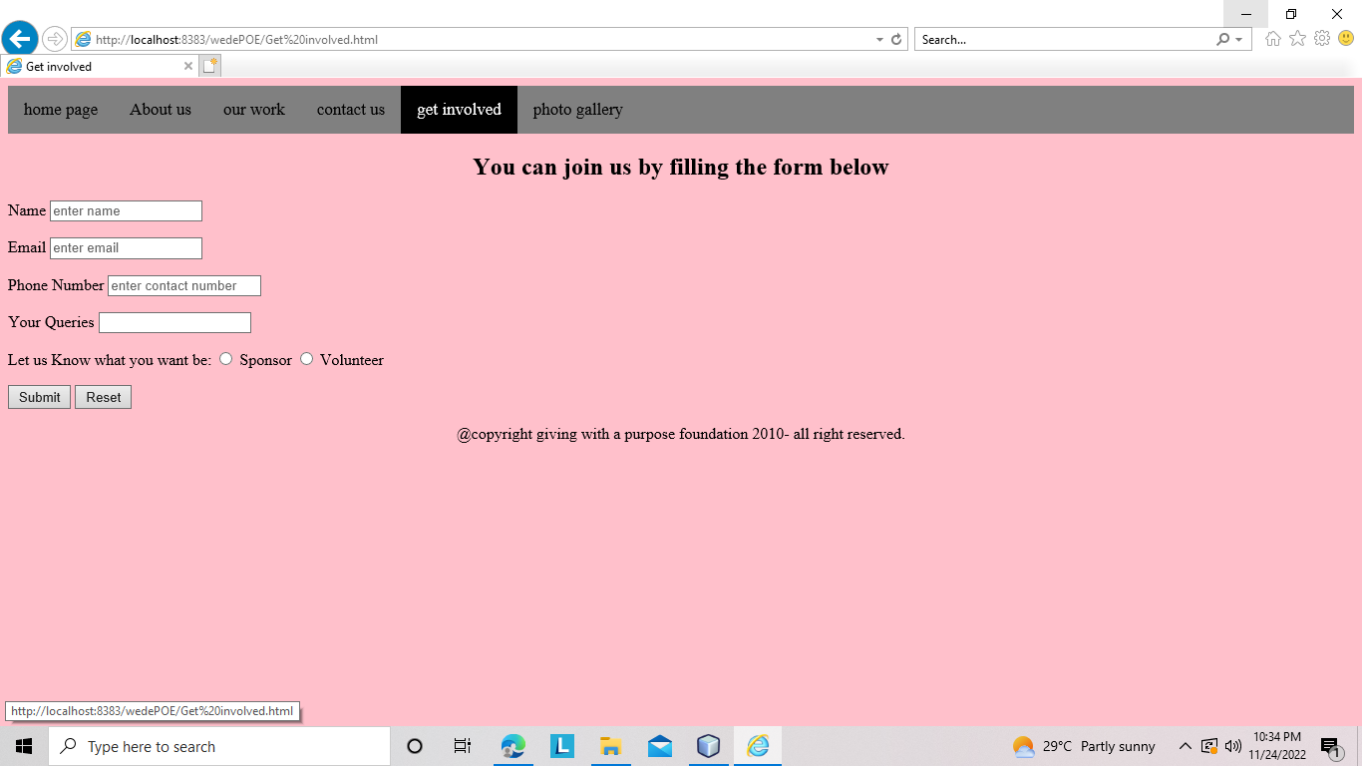

The picture below shows how I improved my “get involved” page after I got feedback. I improved by making sure it was well designed and styled. And by changing the font and color of h1 :

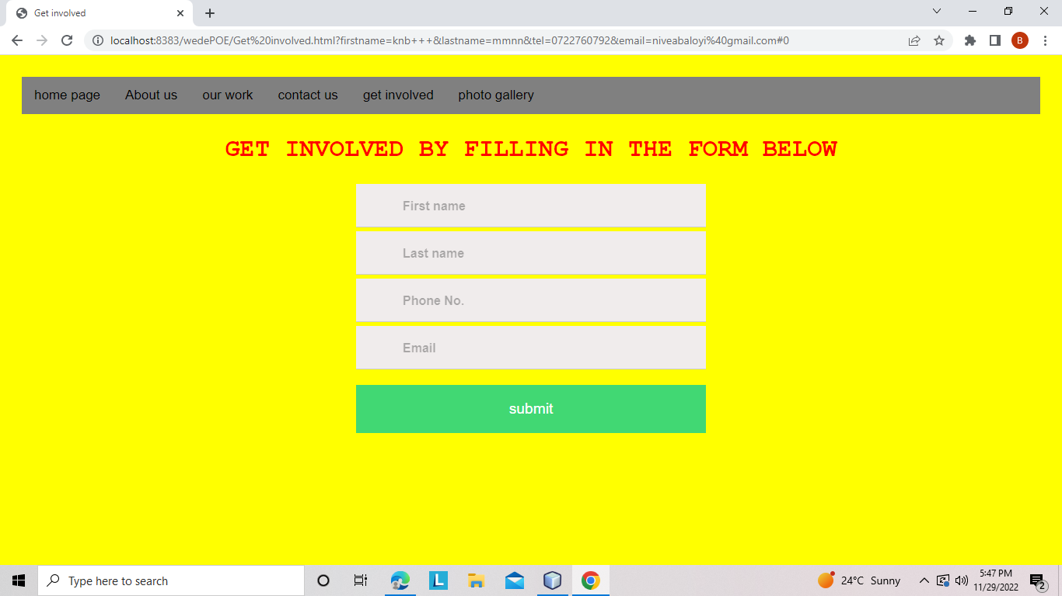

The screenshot below shows how my “about us” page looked like before I got feedback:

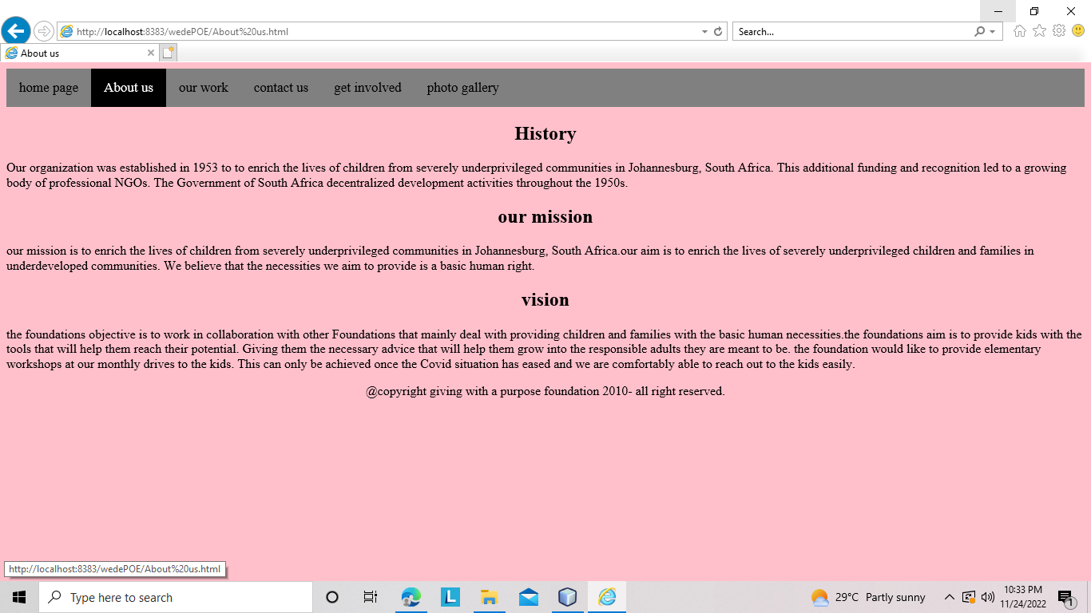

the below screenshot shows hoe I improved my “about us” page after I got feedback. I improved it by making sure it was well styled and displayed. By changing the font, font colour and the size of the text.

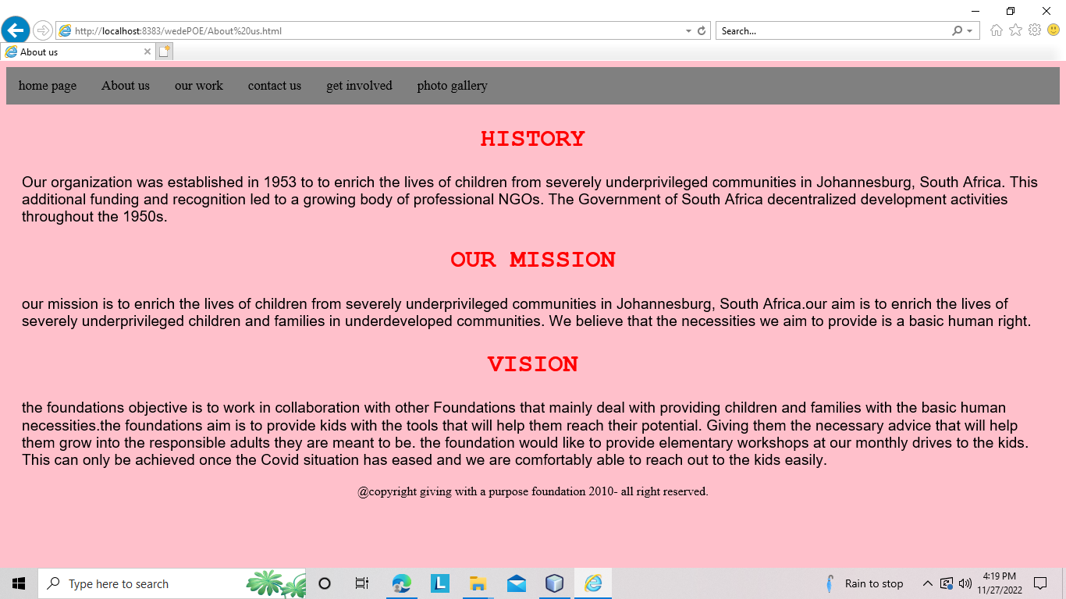

The picture below shows my “our work” page looked like for part one:

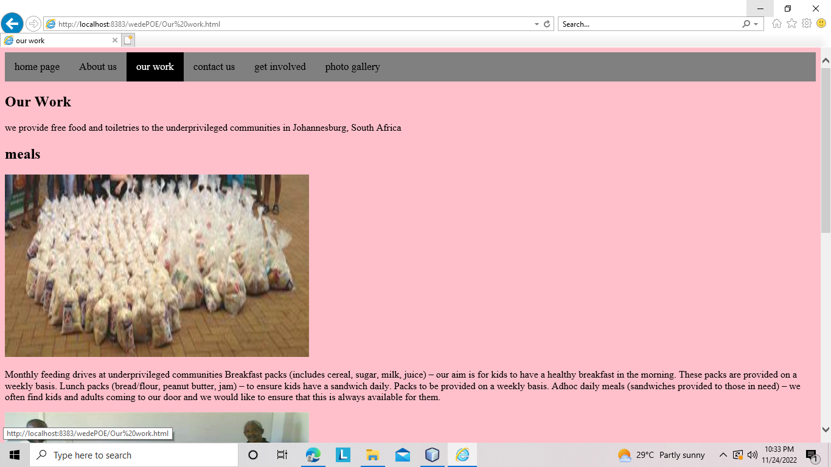

The picture below shows how I improved after I got feedback. For part 2 I improved my webpage by styling it properly. By changing the font , text size and the way the text was displayed.

